CE2107 Lab4 Assignment Sheet (to be submitted to NTULearn before next lab)

Name: Mervyn Chiong Jia Rong Lab Group: SEP4 Date:

1. Section 6.1. What is the issue when an obstacle is place to close to the IR sensor? What can you do to prevent such ambiguity?

**Is more of a characteristic of the IR sensor that will create an ambiguity.**

**When on object is placed closed to the sensor it will show a very high reading and when it is further the reading will drop. However, there is also a case where if the distance between the sensor is very small it produce a reading similar to that of an object that is very far**

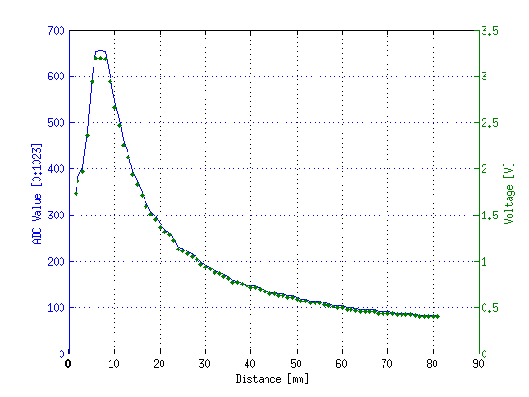

**As depicted by this GP2Y0A21YK graph**

What can we do?

**One easy way is to always start the robot at the peak ADC value above and this would mean your readings will always be correct because you ignore the first part or choose a minimum distance and account if it is within the distance**

1. Section 6.1. What is the purpose of the 10uF decoupling capacitor?  
   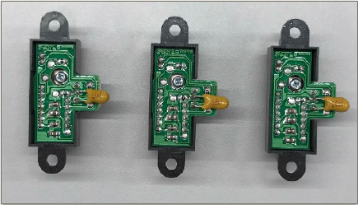

**A decoupling capacitor’s main function is stabilise and reduce noise from the input to the output. In this case since it is connected to a power supply of the sensors, it will reduce the noise from it and thus output a more stabilised reading.**

1. Section 6.2. Which port pins is ADC Ch12, 16 and 17 input mapped to? What is the PSELx settings required to configure the pins to ADC function?

nr = LPF_Calc(raw17); *// right is channel 17 P9.0*nc = LPF_Calc2(raw12); *// center is channel 12, P4.1*nl = LPF_Calc3(raw16); *// left is channel 16, P9.1*

**ADC ch17 mapped to port 9, pin 0 P9.0**

**ADC ch12 mapped to port 4, pin 1 P4.1**

**ADC ch16 mapped to port 9, pin 1 P9.1**

**PSEL setting**

**P9->SEL0 |=0x03(both pins 0 and 1 for port 9)**

**P9->SEL1 |=0x03**

**P4->SEL0|=0x02(only pin 1)**

**P4->SEL1 |=0x02**

1. Section 6.3. With respect to the ADC on MSP432, what are the two stages involved in every Analog to Digital Conversion of a Analog signal?

**MSP432 uses a 14 bit SAR analogue to digital converter.**

**Extraction of sample of analogue singal and convert the signal value to digital value**

1. Section 6.4. What does the function LPF_Calc() does? What are the initial values of the buffer associated with LPF_Calc()? Why do we need this function?

**LPF_Calc() will compute the digital signal that has been processed from analogue and the data is constantly being refreshed by the code to update values from the sensors and average filtered value is the output reading. This reading will represent the reading for the sensor in the robot**

1. Section 6.4. Describe the algorithm you used to estimate the actual distance based on the IR Sensor value.

**Step 1 place the the machine away from a stationary object like the wall or something and record down the distance and voltage reading from it. Then increment the distance from the wall by a fixed value. I used a distance of 5cm to show a more drastic change of the result.**

**Step 2, constantly increment and record the readings in a txt file or excel file and once you have enough readings. Using mycurvefit.com create a graph V(t) to dist of your points and find best feed line which should generate your A and B values in the formula.**

**Step 3, then code it into the respective functions to give you the proper reading output and for accuracy purpose repeat the experiment from step 1-3 for the other 2 sensors**

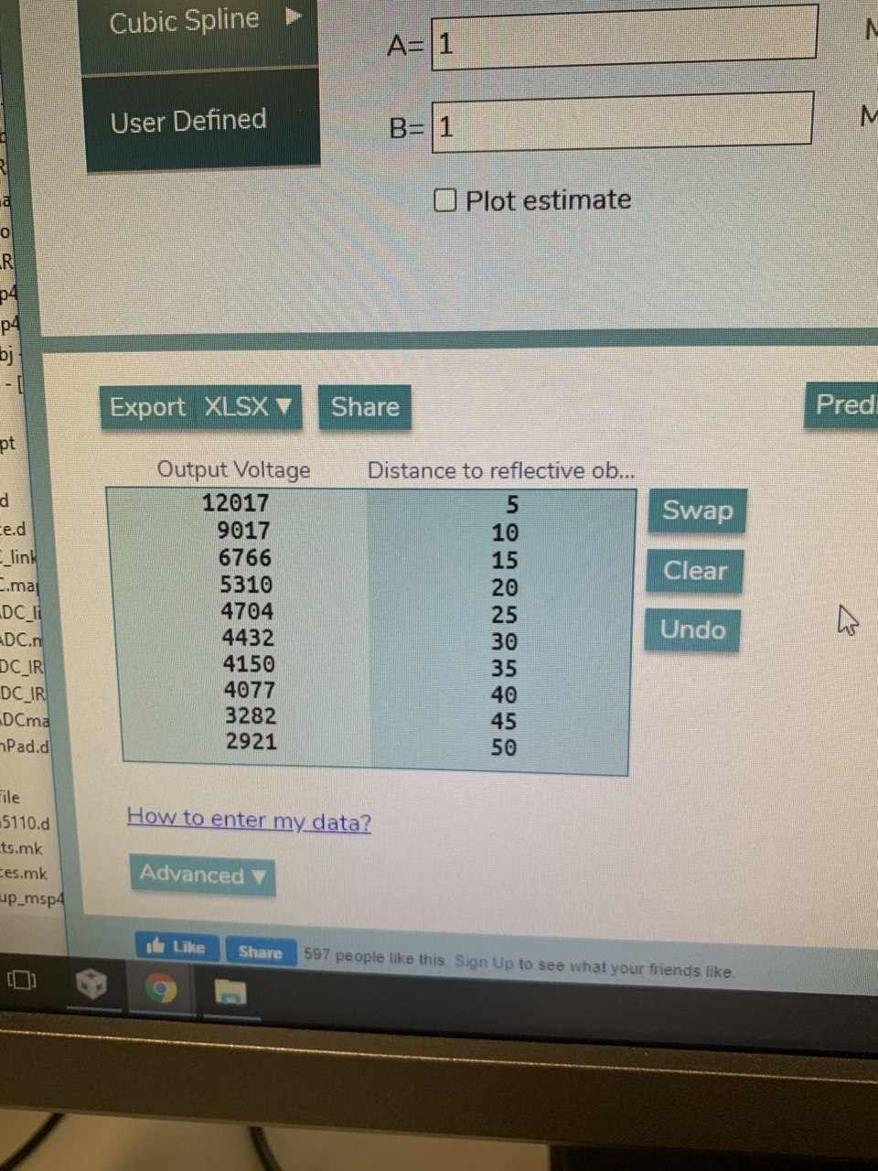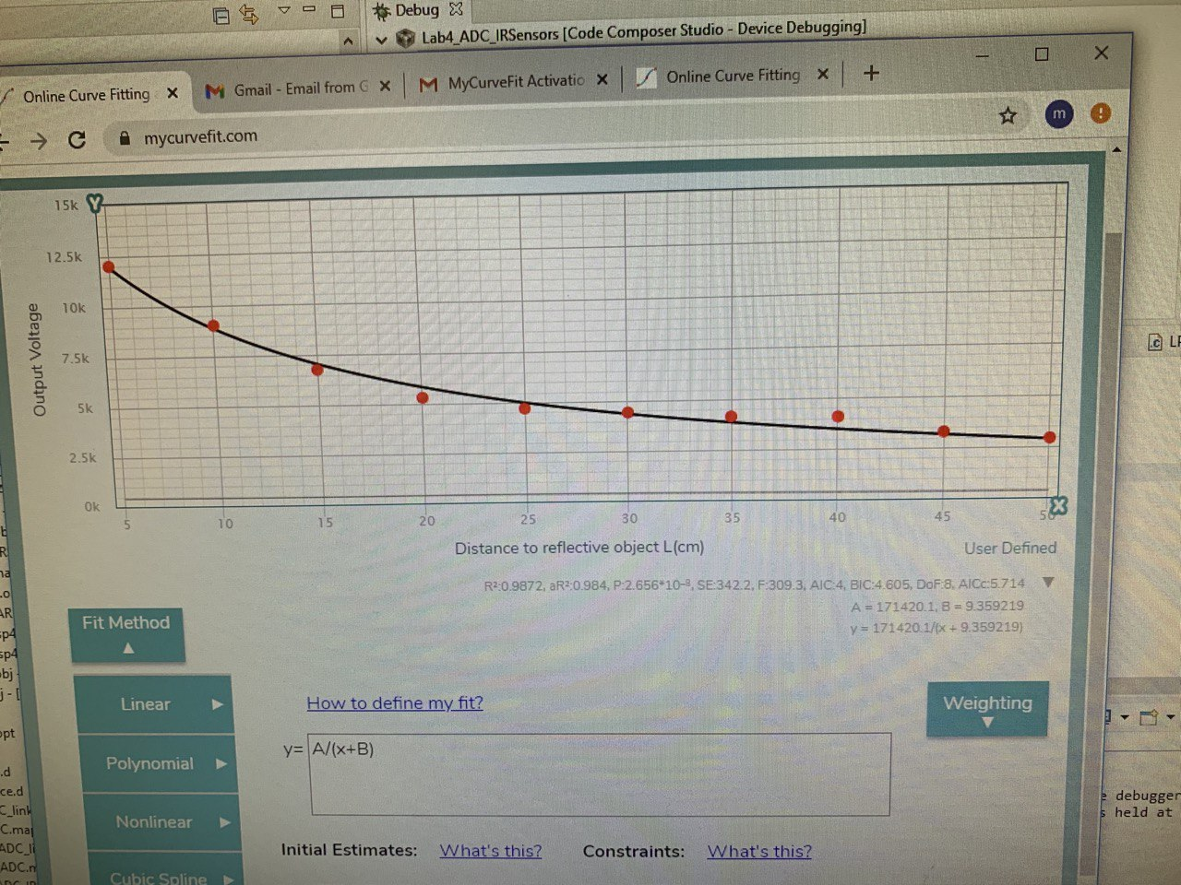

1. Section 7.2. Which timer capture input (Timer and Channel number) does P8.2 and P10.4 correspond to?

**Both corresponds to Timer A3 input**

*// edges of P10.4 (TA3CCP0) and P8.2 (TA3CCP2) and call user*

**From this we can see that 10.4 corresponds to channel 0 since TA3CCP0**

**8.2 corresponds to 2 since TA3ccp2**

1. Section 7.2. Which edge (falling, rising, both) is the timer input capture configured to trigger on? What happens when a capture event occurs?

**Its configured to capture the rising edge of square wave pulses.**

**When it happens the timer value will be saved into the respective CCR registers so in this case channel 0(TA3_0_IRQHandler) and channel 2(TA3_N_IRQHandler) of Timer A3 of the tachometer from lab4 code. Now back to the lab4 code, the PeriodMeasure0 and PeriodMeasure2 will calculate the period of the 2 rising edges and using that calculate the speed of motors rotating and will send the data back.**

1. Section 7.2. Why is the calculated value of pulse duration, derived from the timer capture values, not a constant value but seemed to keep changing?

**This is due to the nature of how the tachometer works here. The tachometer itself has a emitter and a collector that ware at the wheels, so whenever the wheels move the voltage value changes and the slits of the wheels will affect it as such. This value is digitalized to 1 or 0 to create the square wave with rising edges as a result.**

**Due to this, the reading fluctuates as the collector is continuously recording the value at not exactly the same place as the emitter and as such the sampling is not exactly accurate**